
Company
Logotype

Cone Beam Computed Tomography- Report



Porur Dental X-rays & CBCT

Patient Name : Mrs. Vijayakumari | Date of Report : 08.12.2024
Age/ Gender : 51 years/ Female | Region of Interest : CBCT Full Skull
Referring doctor: Dr. Mothishwaran | Indication : Implant assessment
Clinical Notes: Nil
PATIENT INFORMATION

CBCT- Full skull provided
CBCT – IMAGE DETAILS

RADIOGRAPHIC INTERPRETATION

- Completely edentulous maxillary alveolar ridges.
- Retained root stump: 47 region (2.4 mm below the alveolar ridge)
- Complete resorption of maxillary alveolar ridge resulting in narrow maxillary arch in anterior and posterior region causing reduced height of maxillary alveolar ridge.
- The pterygoid plates in both sides are present with normal bone density and hence can be considered for implant placement.
- The mandibular alveolar ridge is also present with mild resorptive changes thereby resulting in minimally reduced mandibular height.

IMPLANT ASSESSMENT

 | 11 region | 12 region | 13 region | 14 region | 21 region | 22 region | 23 region | 24 region
Sub-Crestal | 2.6 | 2.3 | 2.3 | - | 2.5 | 2 | 2.2 | -
Mid- Crestal | 4.2 | 2.9 | 3.1 | - | 2.7 | 2.5 | 1.9 | -
Distance between the alveolar ridge and Floor of the Nasal cavity (in mm) | 10.5 | 9.4 | 9.9 | 2 | 11.3 | 11.3 | 10.5 | 2.1

 | 15 region | 16 region | 17 region | 25 region | 26 region | 27 region
Sub-Crestal (in mm) | - | - | - | - | - | -
Mid- Crestal (in mm) | - | - | - | - | - | -
Distance between the alveolar ridge and floor of the maxillary sinus (in mm) | 1.6 | 1 | 0.9 | 1.6 | 0.7 | 0.7

 | 31 region | 32 region | 33 region | 34 region | 41 region | 42 region | 43 region | 44 region
Sub-Crestal | 1.6 | 2.7 | 1.7 | 3.5 | 3.2 | 3.8 | 3.7 | 4.3
Mid- Crestal | 3.6 | 4.1 | 3.4 | 4.4 | 4.8 | 5.3 | 4.9 | 6.9
Distance between the alveolar ridge and lower border of mandible (in mm) | 22.4 | 22.2 | 23.9 | 24.3 | 21.6 | 21.4 | 21.4 | 20.2

 | 35 region | 36 region | 37 region | 45 region | 46 region | 47 region
Sub-Crestal (in mm) | 4 | 5.3 | 6.1 | 3.8 | 7.1 | 6.1
Mid- Crestal (in mm) | 5.4 | 8.8 | 10 | 7.5 | 8.6 | 8.3
Distance between alveolar ridge and the inferior alveolar nerve canal (in mm) | 12.1 | 10.5 | 0 | 7 | 8.9 | 8.6
Distance between the alveolar ridge and lower border of mandible (in mm) | 23.8 | 20.7 | 18.2 | 20 | 18.1 | 18.7

RADIOGRAPHIC IMPRESSION

- Partially edentulous maxillary and mandibular arch.
- Retained root stump: 47 region

Kindly correlate with clinical findings


IMAGES FOR REFERENCE

RECONTRUCTED PANORAMIC VIEW

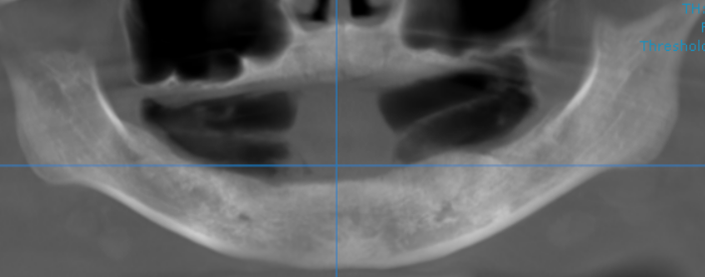

47 REGION
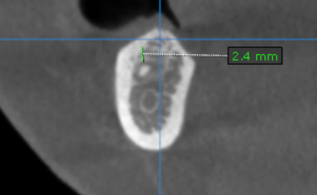

3-DIMENSIONAL VIEW

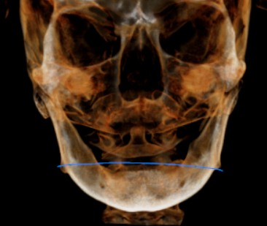

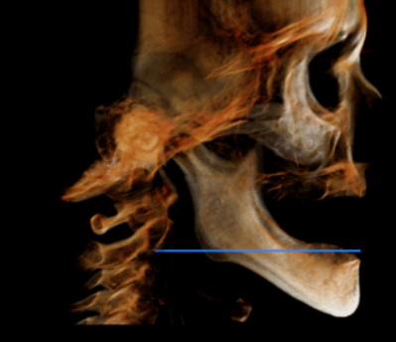
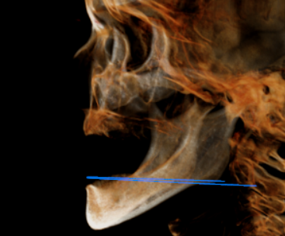

CROSS SECTIONAL VIEW

11 region | 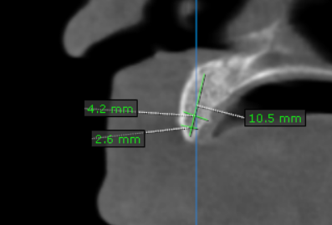
12 region | 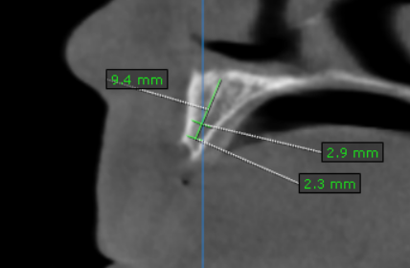
13 region | 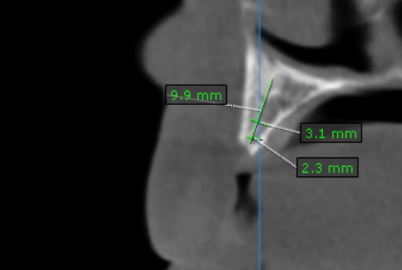
14 region | 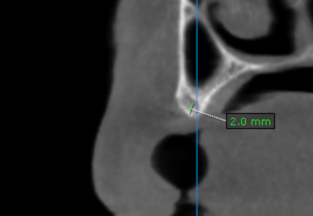
15 region | 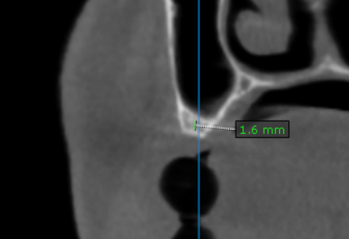
16 region | 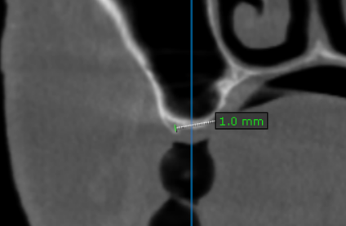
17 region | 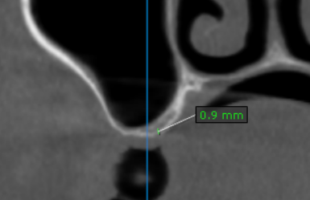
21 region | 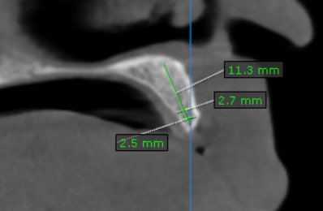
22 region | 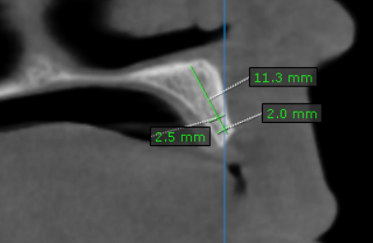
23 region | 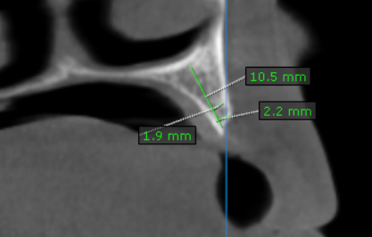
24 region | 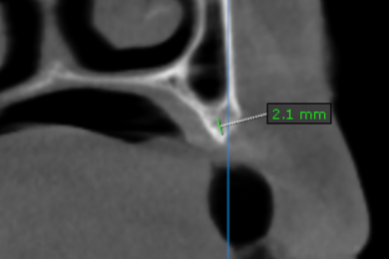
25 region | 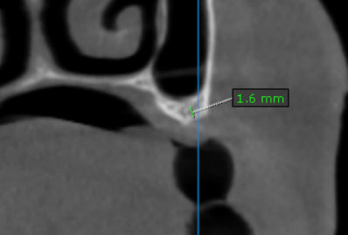
26 region | 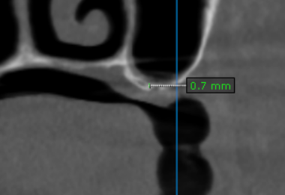
27 region | 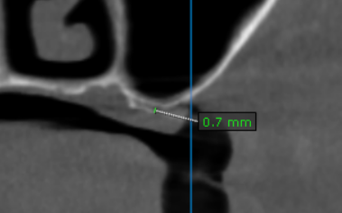
31 region | 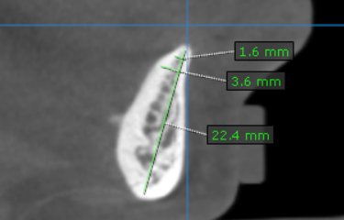
32 region | 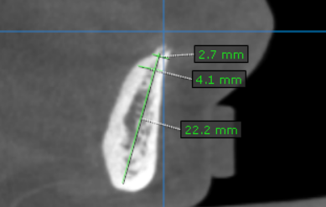
33 region | 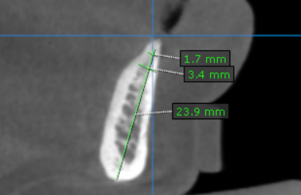
34 region | 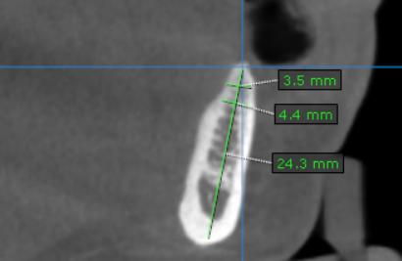
35 region | 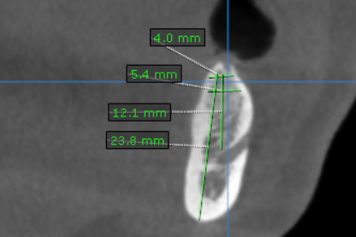
36 region | 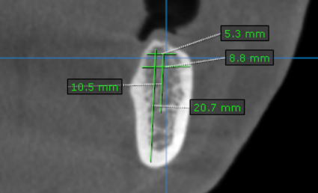
37 region | 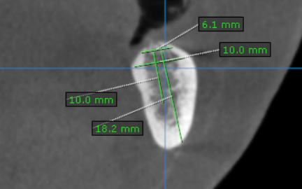
41 region | 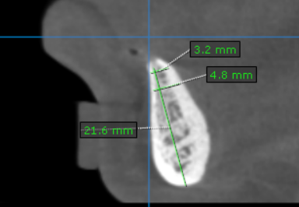
42 region | 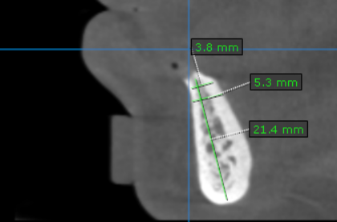
43 region | 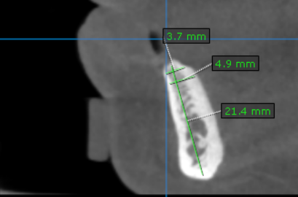
44 region | 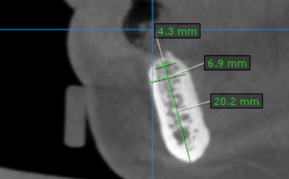
45 region | 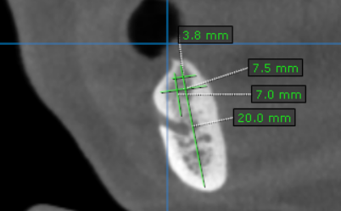
46 region | 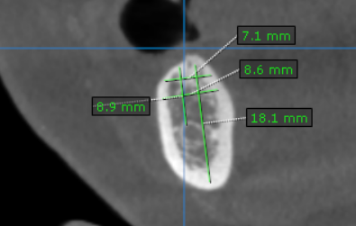
47 region | 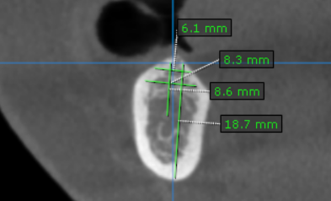

**** End of report ****

